Results after running only DFS on Graph:

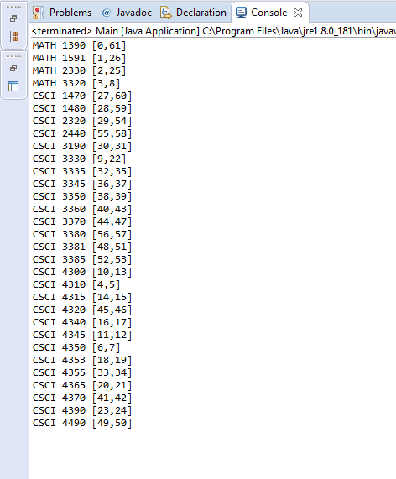

Results after running topological ordering algorithm (rearranging courses according to decreasing post-visit numbers)

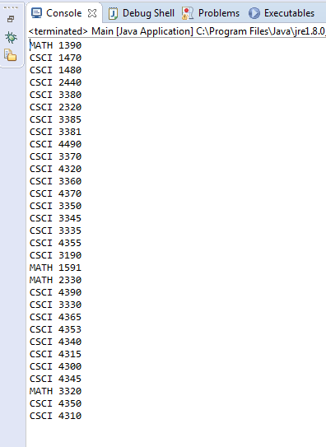

Results after running code for the bonus portion. List of all courses that can be taken together at any one time:

